**Username Enumeration**

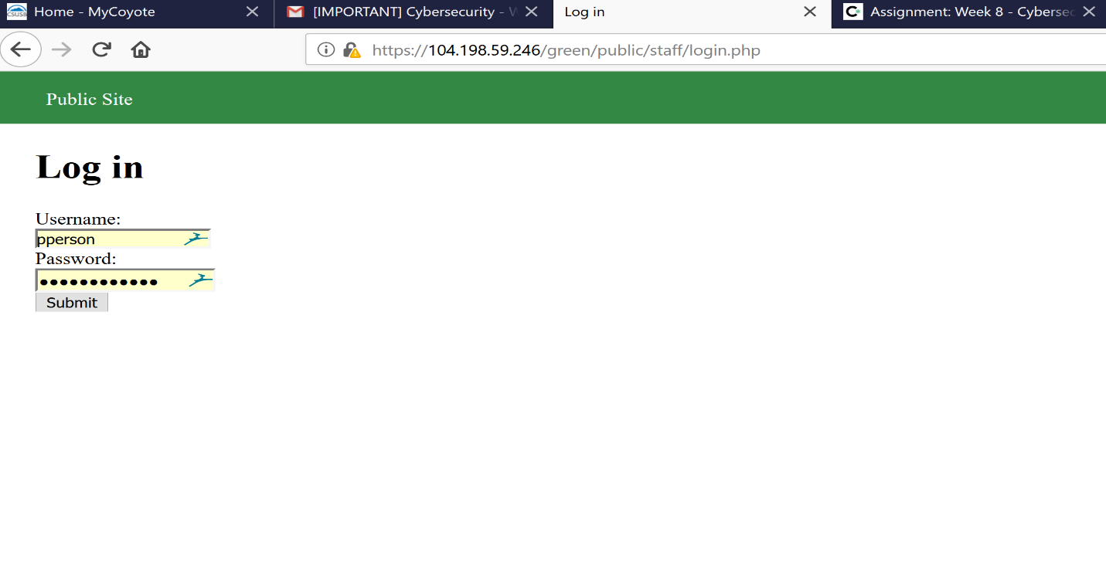

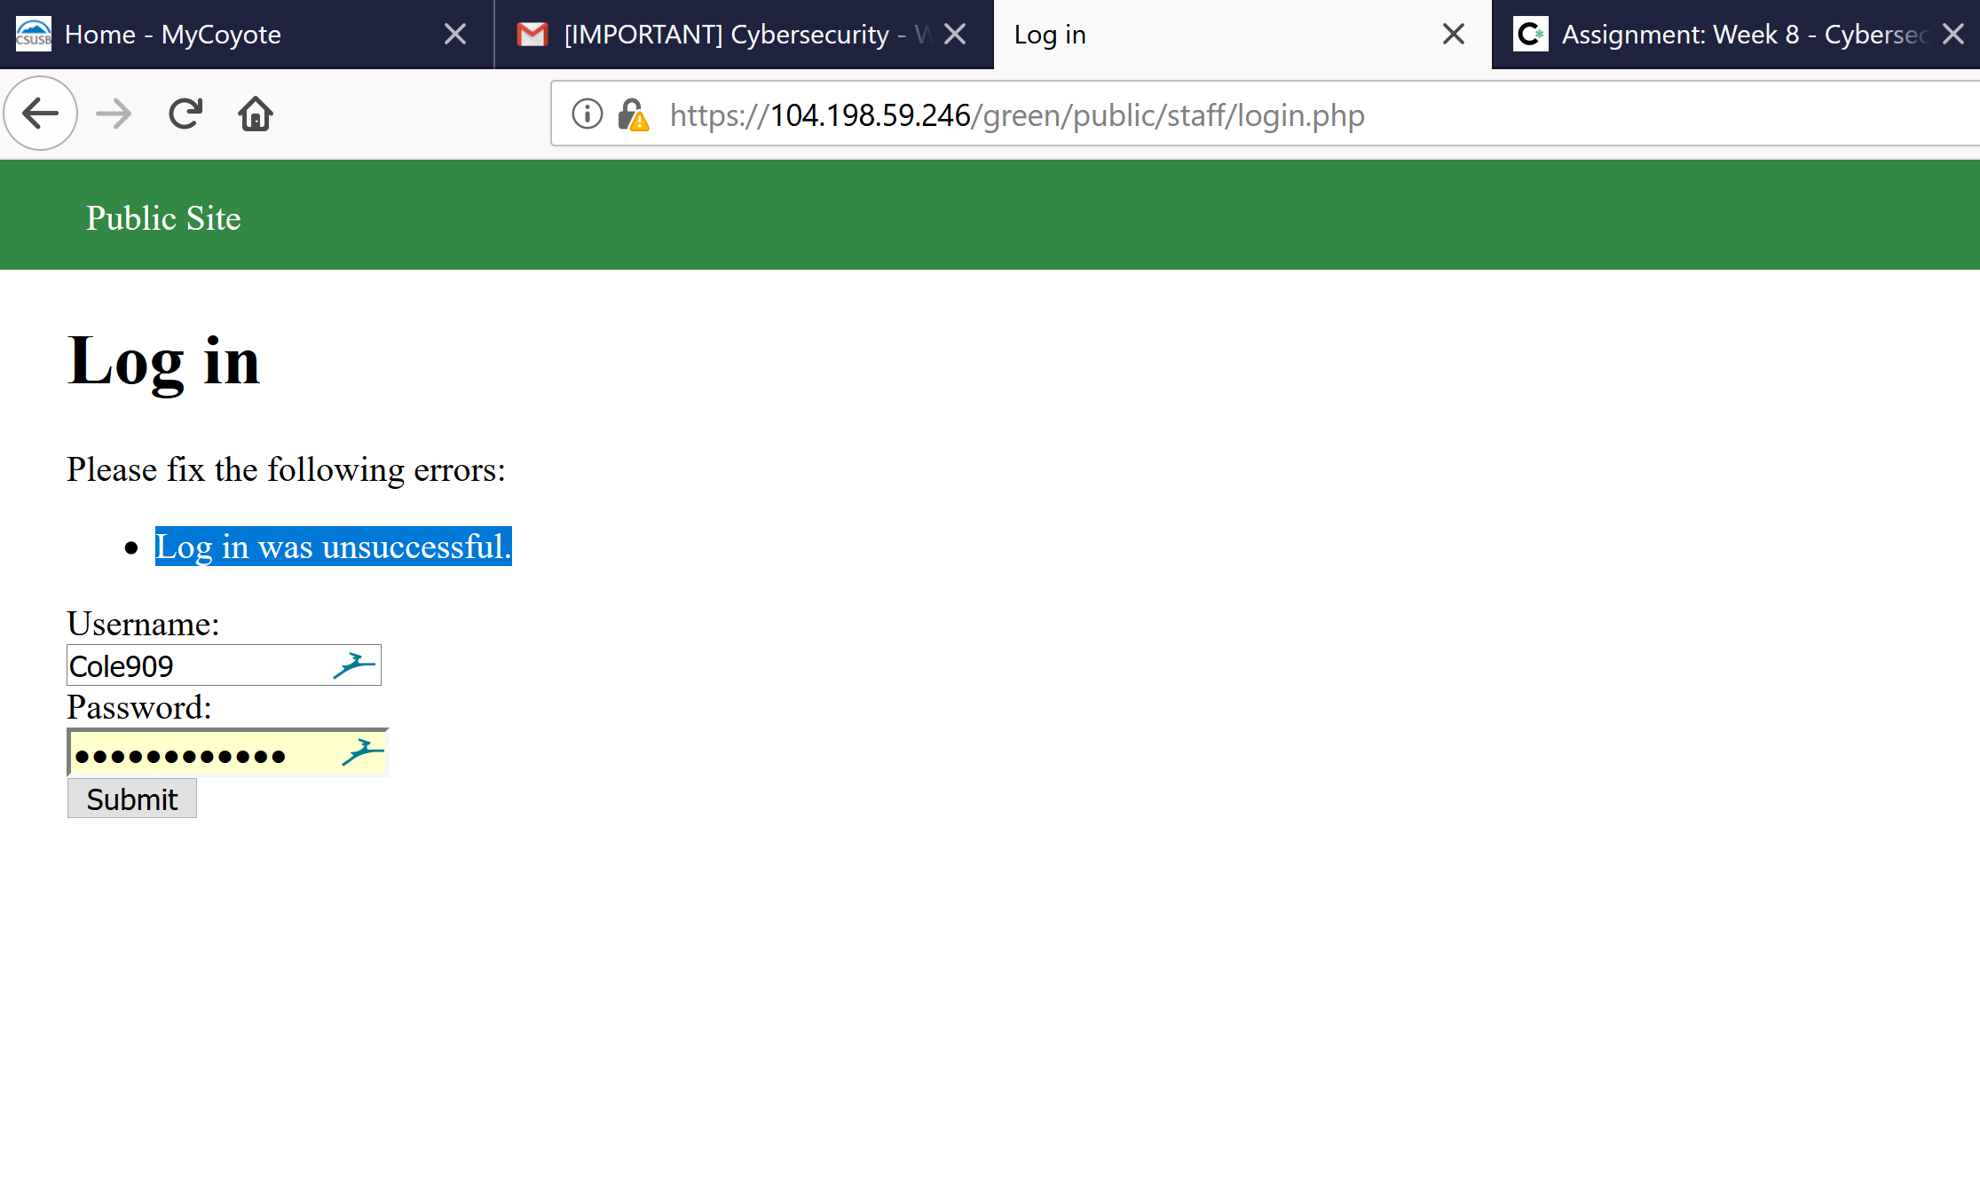

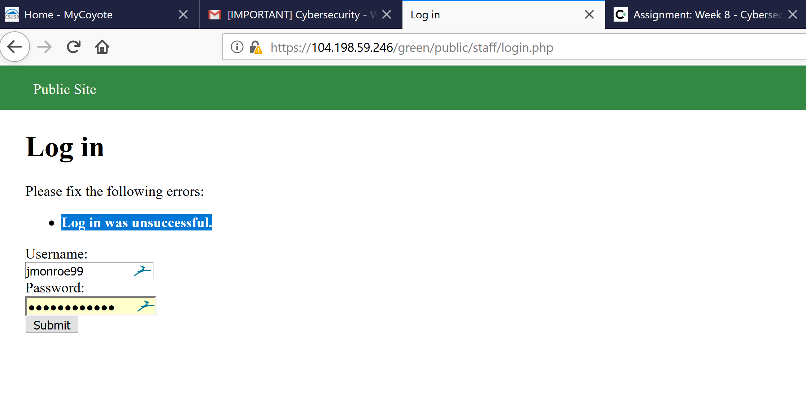

* When logging in with jimonroe99 or Cole909 with random password give you a unsuccessful or error, but when using a valid in the username with a random another random password the text come back in a bold “Log in was unsuccessful” The would be your vulnerability point**.**